**MODULE 1: Introduction to AWS**

**Basic CRUD application** – **C**reate, **R**ead, **U**pdate and **D**elete actions are applicable.

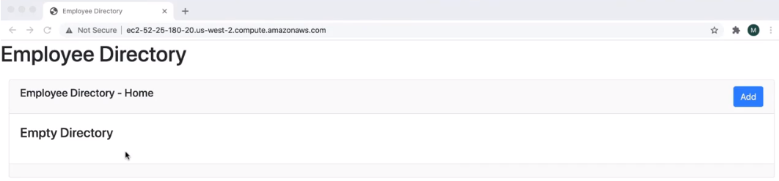

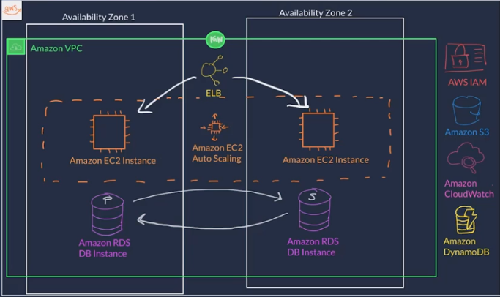

The system in above snippet will be built step by step using “Amazon Management Console” and below are some quick details on the various services being used.

**Amazon VPC** – application will be built on a private network called as “Amazon Virtual Private Cloud”.

**Amazon EC2 Instance** – host the application backend code on “Amazon Elastic Compute Cloud” which is a service that essentially offers a virtual machine on AWS.

**Amazon RDS DB Instance/Amazon DynamoDB** – employee data will be stored on this service offered by AWS named as “Amazon Relational Database Service” or “Amazon DynamoDB”.

**Amazon S3** – The images/photos of the employee’s will be stored using object storing AWS service named “Amazon Simple Storage Service” and it allows unlimited storage of any file type.

**Amazon CloudWatch -**  used for monitoring the system setup and alert, in case of issues.

**ELB** – we will need this service for scalability and flexibility called as “Elastic Load Balancer”. This will distribute the traffic across different Amazon EC2 instances and maintain the balance.

**Amazon EC2 Auto Scaling** – We will use this service to scale up (or) scale down the services in use based on the system/traffic in demand (high or low).

**Amazon IAM** – For security and identity, we will be using this service named “Amazon Identity and Access Management”.

**What is AWS?**

* Cloud computing is an on-demand delivery of IT resources over the internet with primarily pay-as-you-go pricing.
* With cloud computing, companies do not have to manage and maintain their own hardware and data centers.
* Instead, companies like AWS own and maintain data centers and provide virtual data center technologies and services to companies and users over the internet.
* AWS provides cloud computing services.
* The IT resources mentioned in the cloud computing definition are AWS services.
* For this course's corporate directory application (*Employee Directory*), you will use AWS services to architect a scalable, highly available, and cost-effective infrastructure to host the corporate directory application.

Advantages of Cloud Computing:

* Pay as you go
* Benefits from massive economies of scale
* Eliminate guessing on your infrastructure capacity needs.
* IT resources are only a click away, which means that you reduce the time to make resources available to your developers from weeks to minutes.
* Realize cost savings. Companies can focus on projects that differentiate their business instead of maintaining data centers
* Go global in minutes.

Types of Cloud Computing:

**Cloud Computing Models**

Infrastructure as a Service (IaaS)

* IaaS contains the basic building blocks for cloud IT and typically provides access to n/w features, hardware and data storage space. This service will be same as the existing IT resources that we know. Ex. **Amazon EC2**.

Platform as a Service (PaaS)

* Removes the need of the company to manage the underlying infrastructure such as hardware and OS and allows the company to focus on the deployment and management of the application.
* This helps as you do not need to worry about resource procurement, capacity planning, s/w maintenance, patching or any other heavy lifting involved in your running application. Ex. **Elastic Beanstalk**.

Software as a Service (SaaS)

* Provides you with a completed product/software that is run and managed by the service provider. You only need to think about how you will use that particular piece of software.
* A common example of a SaaS application is web-based email which you can use to send and receive email without having to manage feature additions to the email product or maintain the servers and operating systems that the email program is running on. Ex. **Facebook**.

**Cloud Computing Deployment Models**

Cloud

A cloud based application is fully deployed in the cloud and all parts of the application run in the cloud.

Hybrid

A hybrid deployment is a way to connect infrastructure and applications between cloud-based resources and existing resources that are not located in the cloud.

On-premises / Private Cloud

On-premises deployment doesn’t provide many of the benefits of cloud computing but is sometimes sought for its ability to provide dedicated resources.

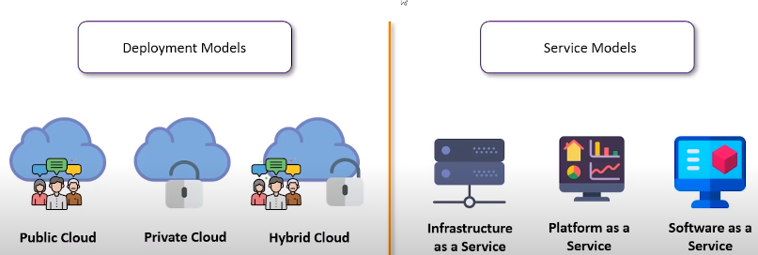

**AWS Global Infrastructure:**

Availability Zones (AZ) -

Availability Zones consist of one or more discrete data centers, each with redundant power, networking, and connectivity, housed in separate facilities.

Regions -

AWS Region is a geographic/physical location in the world where we have multiple Availability Zones. Cluster of AZ’s is called a Region.

Here are examples of Region codes:

**us-east-1**: The first Region created in the eastern US area. The geographical name for this Region is N. Virginia.

**ap-northeast-1**: The first Region created in the northeast Asia Pacific area. The geographical name for this Region is Tokyo.

Four aspects to ponder on before selecting an AWS Region for your activity.

Compliance – For example, if an UK based company is restricted to store its data within UK borders then they need to choose London region to comply with their regulatory demand.

Latency – Is all about how well the company’s IT resources are closer to the user base. For quickness in data retrieval and usage is the prime motto in this case.

Pricing – Pricing can vary from region to region. For example, the Sao Paolo region is expensive due to strict tax rules.

Service Availability – When AWS releases a new service, then initially it will be available in selected regions only. Hence, the company needs to choose the region based on whether it needs the newly launched service immediately or not.

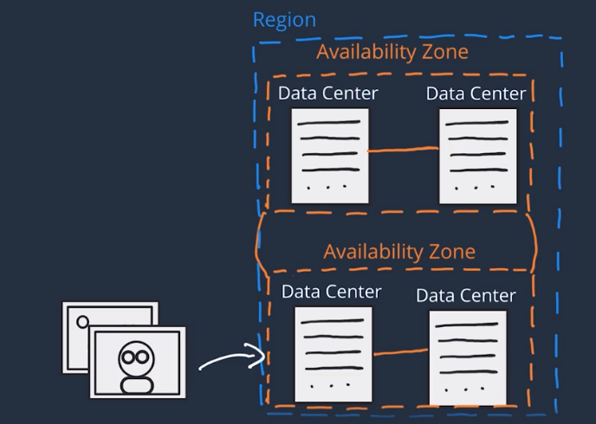

**Interacting with AWS:**

For logically handling the virtual server/infrastructure, we need to use **Application Programming Interface (API)**. We need to perform an API call to do any operations on the virtual server at AWS.

Ways to interact with AWS API:

AWS Management Console –

web based console that we login from the browser using point & click ability to use some of the services. We need not worry about scripting or follow a certain code syntax.

The services are placed in categories, such as Compute, Storage, Database, and Analytics.

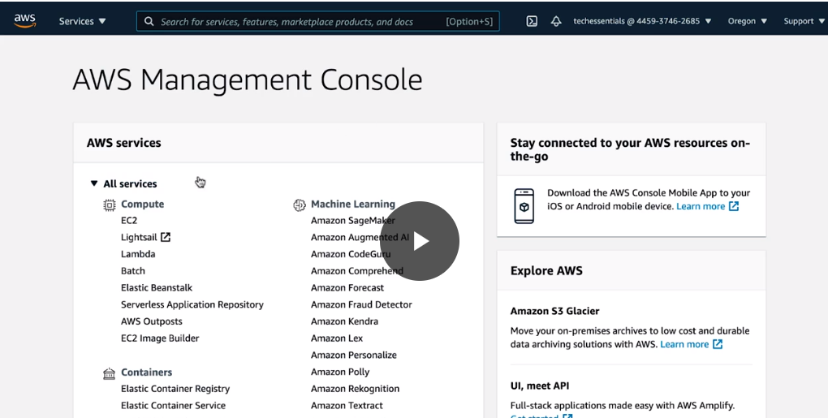

AWS Command Line Interface (AWS CLI) –

We can download this tool and use the command-line to create and use the AWS services manually. Commands being used here needs to follow a pre-defined AWS syntax.

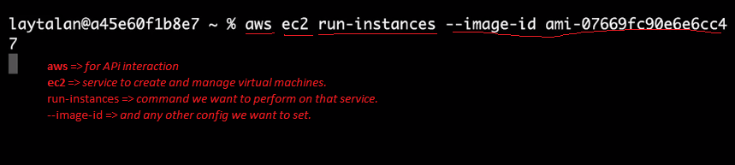

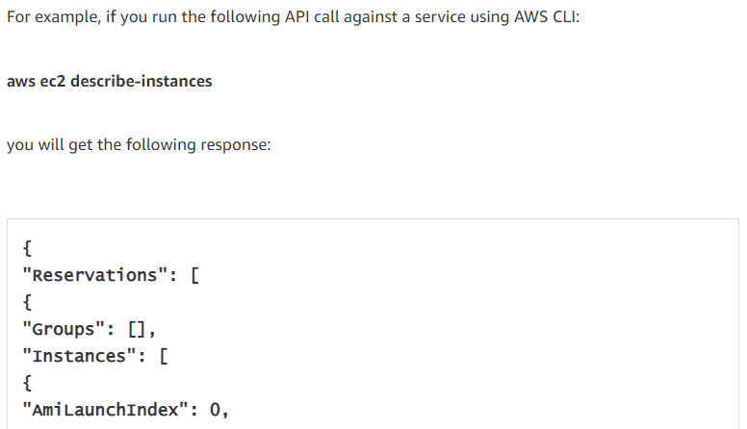

AWS Software Development Kit (SDK’s) –

API calls to AWS can be performed by SDK’s which are created and maintained by AWS for the most popular programming languages such as Python, Java, NodeJs, Ruby and so on. For example, our Employee Directory application uses Python and Flask and If I need to store data using AWS S3 then I will be using the Python SDK to interact with the same.

**Security and the AWS Shared Responsibility Model**

AWS follows a “Shared Responsibility” security model which makes sure that both the Customer and AWS are responsible for managing the security of the system.

The distinction of responsibility is commonly referred to as *security OF the cloud* versus *security IN the cloud*.

AWS – Responsibility for security ‘OF’ the cloud.

* Protecting and securing AWS Regions, Availability Zones, and Data Centers, down to the physical security of the buildings.
* Managing the hardware, software, and networking components that run AWS services, such as the physical servers, host operating systems, virtualization layers, and AWS networking components.

CUSTOMER – Responsibility for security ‘IN’ the cloud.

* You are responsible for OS patches, firewall configuration, IAM and your data maintenance.

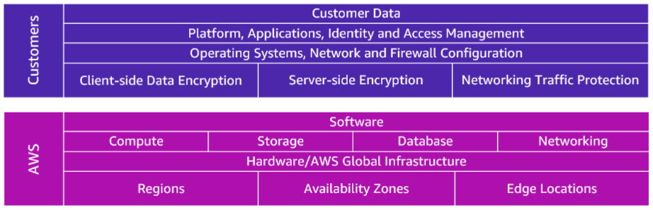

The level of responsibility in AWS depends on the service. AWS classifies services into three categories.

|  |  |  |  |
| --- | --- | --- | --- |
| **Category** | **Examples of AWS Services in the Category** | **AWS Responsibility** | **Customer Responsibility** |
| Infrastructure Services | Compute services such as **Amazon EC2** | AWS manages the underlying infrastructure and foundation services. | You control the OS and application platform, in addition to encryption, protecting, and managing customer data. |
| Container Services | Services that require less management from customer, such as **Amazon RDS** | AWS manages the infrastructure and foundation services, OS, and application platform. | You are responsible for customer data, encrypting the data, and protecting it through n/w firewalls and backups. |
| Abstracted Services | Services that require very little management from customer, such as **Amazon S3** | AWS operates the infrastructure layer, OS, and platforms, in addition to server-side encryption and data protection. | You are responsible for managing customer data and protecting it through client-side encryption. |

**Protect the AWS Root User**

* The email address used during sign-up becomes the “Root User” of the AWS account.
* Single-Factor Authentication: Match the email address with the password and you are logged-in.
* Multi-Factor Authentication (MFA): for the root user and adds variety of authentication layers to protect from unwanted logins such as OTP or Secure Token generated by the MFA device.
* The AWS root user has two sets of credentials associated with it –
  + Email Address and Password used to create the account which allows to access the AWS Management Console.
  + Access keys, which allow you to make programmatic requests from the AWS Command Line Interface (AWS CLI) or AWS API.

Access keys consist of two parts:

**Access key ID**, for example, A2lAl5EXAMPLE

**Secret access key**, for example, wJalrFE/KbEKxE

Similar to a user name and password combination, you need both the access key ID and secret access key to authenticate your requests via the AWS CLI or AWS API.

**AWS Identity and Access Management (**IAM**)**

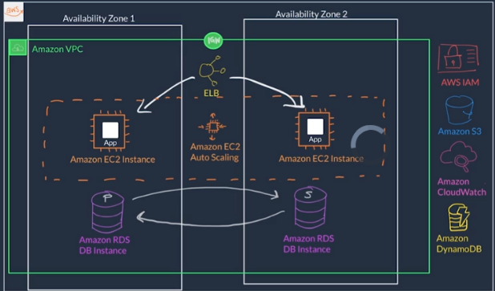

1. How user’s login to the application using UID and PWD which is the access management on the application level.

**Application Level Access Control**

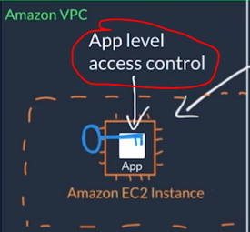

1. We know that the application is hosted on a virtual machine via the service provided by AWS named “EC2” which needs to make API calls with the Amazon S3 service to retrieve the photo information.

All AWS API calls must be signed and authenticated, no matter they live in the same system setup or not.

Hence, here we need the access and credential management as well to make the EC2 and S3 to interact via API calls.

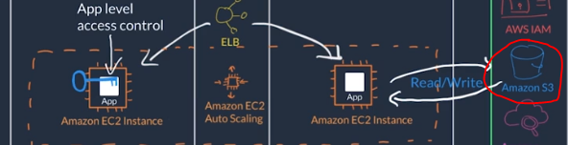

1. How will you build this setup? For that you would need access to AWS account via UID and PWD and also, should have necessary permissions to perform these actions and use the AWS services.

Root User has permissions but we should not use this ID for this activity.

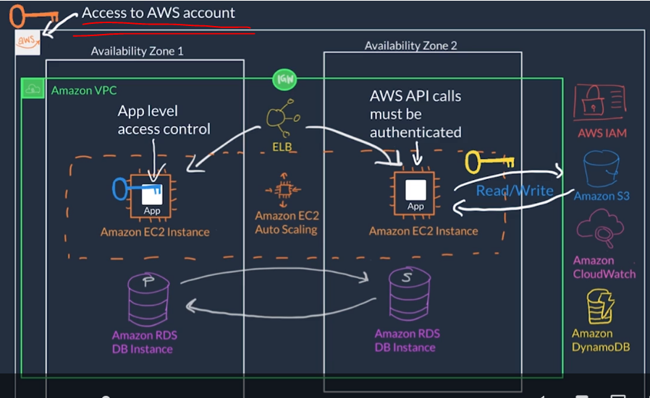

* AWS IAM is **responsible** only for below:
  1. Access to AWS Account
  2. Access to perform API calls between various AWS services.
* AWS IAM is **not responsible** for application level access control & management.
* AWS IAM can take care of the “**Authentication**” role
* but for the “**Authorization**” part meaning whether you have necessary authority or not to use certain AWS services & perform action (AWS API calls) can be taken care by using **IAM policies** to “Grant or Deny permission to take actions”.
* **All the actions in AWS are API calls** and policies are stored in AWS in **JSON format**.

Below policy has four major JSON elements: *Version*, *Effect*, *Action*, and *Resource*.

Sample:

(Image 1) This means all ec2.* related actions are allowed. Also referred as “Admin Policy”.

(Image 2) This means the user can perform only “Run Instances” action and nothing else.

(Image 3) This means actions can be performed only on those resources (*in yellow*).

(Image 4) We can give specific conditions to the IAM policy.

(Image 5) IAM policy can be attached to a group of users as well. All the users in that group will inherit the IAM policy features.

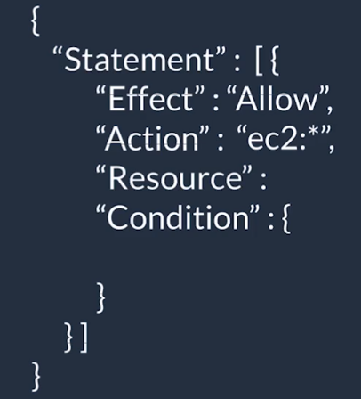 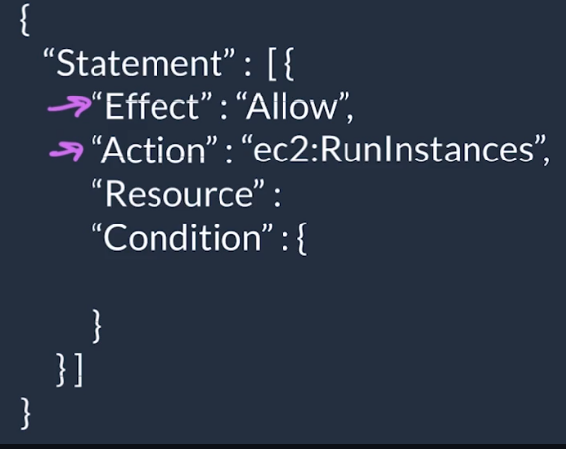 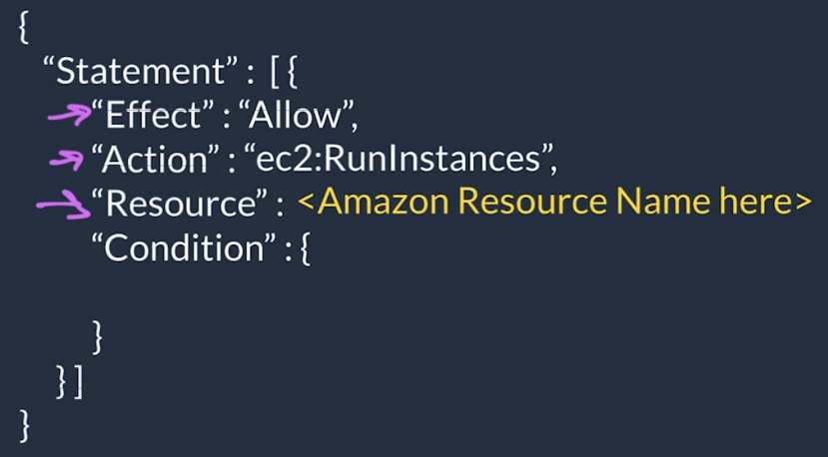

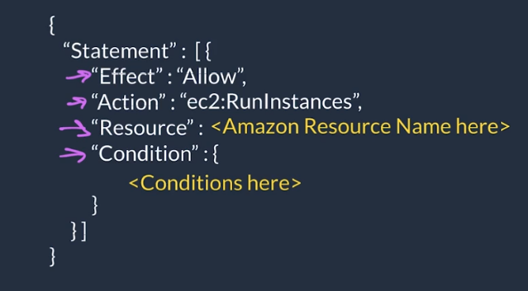 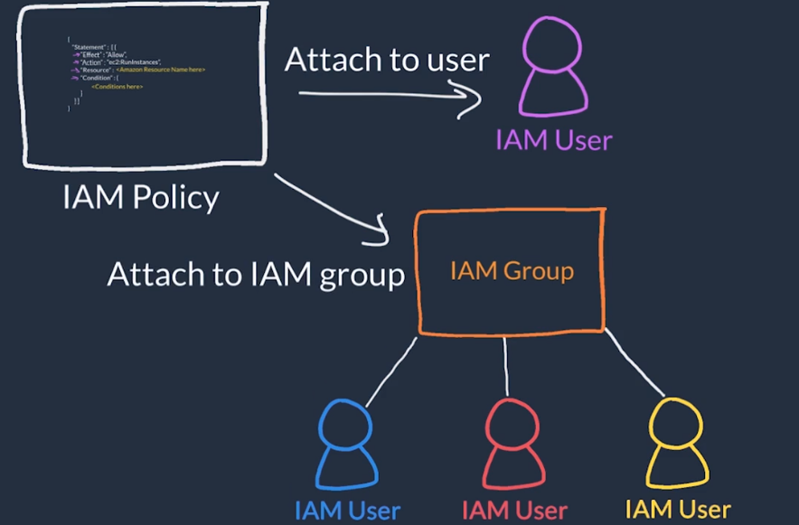

* Another example to show more granular IAM policy.

|  |  |
| --- | --- |
| {  "Version": "2012-10-17",  "Statement": [{  "Effect": "Allow",  "Action": [  "iam: ChangePassword",  "iam: GetUser"  ]  "Resource":"arn:aws:iam::123456789012:user/${aws:username}"  }]  } | This policy allows the IAM user to change their own IAM password (iam:ChangePassword) and get information about their own user (iam:GetUser).  It only permits the user to access their own credentials because the resource restricts access with the variable substitution ${aws:username}. |

* When creating a policy, each of these elements are required in the policy statement as shown below.

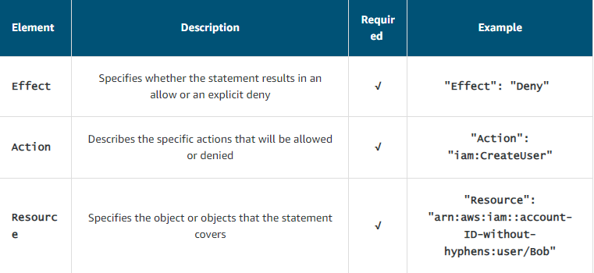

* Best Practice => Login using a root user and then create an IAM user giving admin privileges. And now, log off from the root user and use the IAM admin user to login and proceed with your work. Also, you cannot apply a policy to root user but can be applied on the IAM admin user.
* Using IAM, we can achieve control on the below part only.

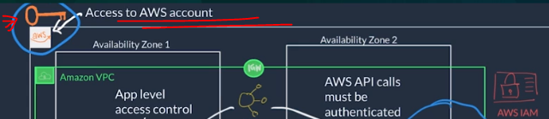

* Using IAM Roles, we can manage the API calls between Amazon EC2 and Amazon S3 services.

**Role-Based Access in AWS (IAM Roles)**

* IAM roles are identities in AWS that like an IAM user also have an associated AWS credentials used to sign requests.
* IAM users have username & pwd and as well as static credentials (access key + secret access key).
* IAM roles do not have any login credentials (no static login credentials) instead
  + They are assumed programmatically.
  + Credentials are temporarily acquired for a configurable amount of time.
  + Credentials expire and are rotated.

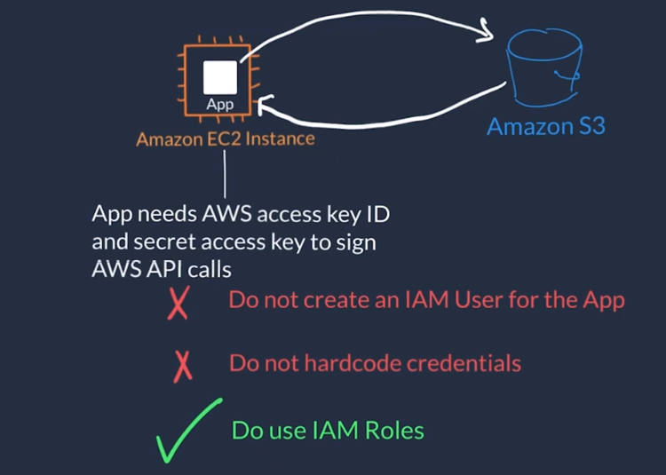

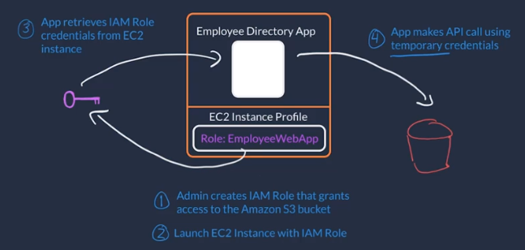

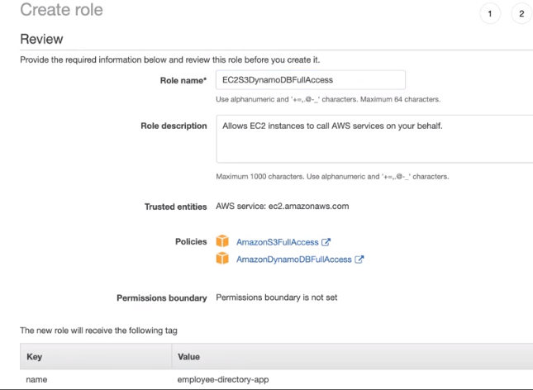

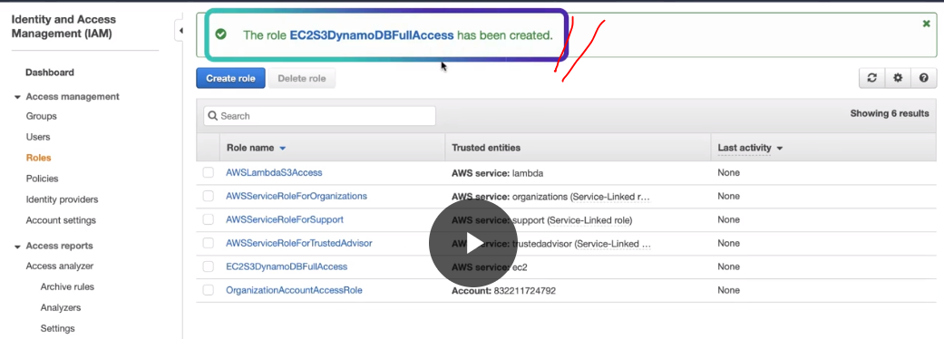

**External Identity Providers** ->

* In this case, AWS provides a “**Federated Role**” to use the AWS services instead of creating multiple IAM roles for each employee (~5000). This external provider can identify all those employees which will be leveraged by the AWS services to assign roles.
* Use the existing “IAM Roles” to give access to the users in the enterprise user directory provided by the Identity Provider. These users are known as “**Federated Users**”.
* AWS assigns a role to the federated users when access is requested through an Identity Provider.
* AWS has another service named “AWS Single Sign On” / **AWS SSO** which can help achieving this role assignment.

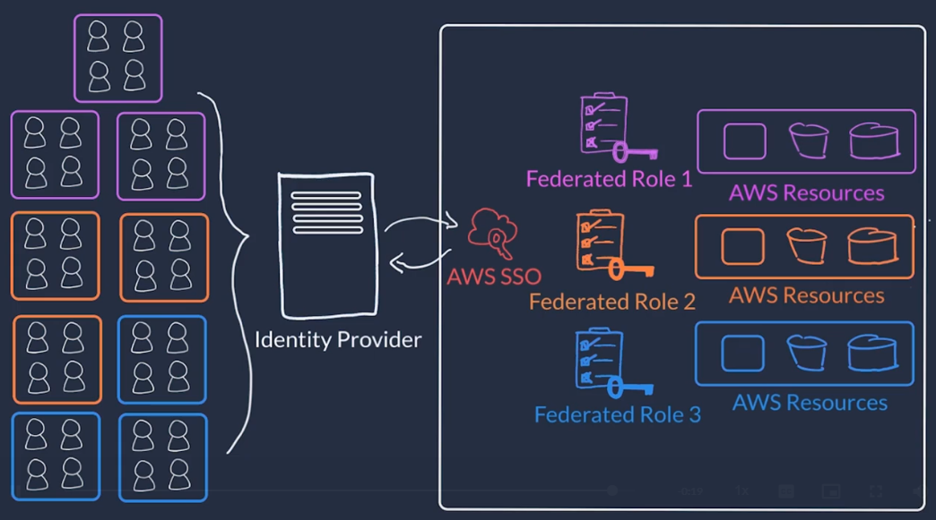

**Most important IAM best practices** that you must be familiar with before building solutions in AWS.

1. Lock down the AWS root user.
   1. Don’t share the credentials associated with the root user
   2. Consider deleting the root user access keys
   3. Enable MFA on the root account
2. Follow the principle of least privilege –

To implement least, privilege for access control, start with the minimum set of permissions in an IAM policy and then grant additional permissions as necessary for a user, group, or role.

1. Use IAM appropriately.
   1. It simply provides a way to create and manage users, groups, and roles to access resources in a single AWS account.
   2. IAM is not used for website authentication and authorization.
   3. IAM also does not support security controls for protecting operating systems and networks.
2. Use IAM roles when possible.
   1. When you assume a role, IAM dynamically provides temporary credentials that expire after a defined period of time, between 15 minutes and 36 hours.
   2. Users, on the other hand, have long-term credentials in the form of user name and password combinations or a set of access keys.
   3. User access keys only expire when you or the account admin rotates the keys.
   4. User login credentials expire if you applied a password policy to your account that forces users to rotate their passwords.
3. Consider your identity provider(IdP)
   1. If you decide to make your cat photo application into a business and begin to have more than a handful of people working on it, consider managing employee identity information through an identity provider (IdP).
   2. Using an IdP, whether it's an AWS service such as AWS Single Sign-On or a third-party identity provider, provides a single source of truth for all identities in your organization.
   3. Use IAM roles to provide permissions to identities that are federated from your IdP.
4. Consider AWS SSO
   1. AWS SSO is an IdP that lets your users sign in to a user portal with a single set of credentials. It then provides users access to their assigned accounts and applications in a central location.

**Demonstration: Implement security with AWS Identity and Access Management (IAM)**

We want to configure 3 users each one of them unique permissions as detailed below.

1. user-1 will have Read-only permission on Amazon S3.
2. user-2 will have Read-only permission on Amazon EC2.
3. user-3 will have ability to View, Stop and Start the Amazon EC2 services.

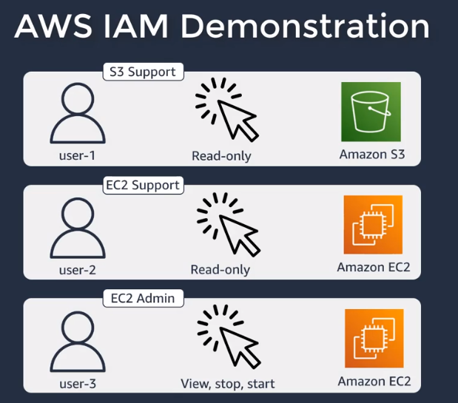 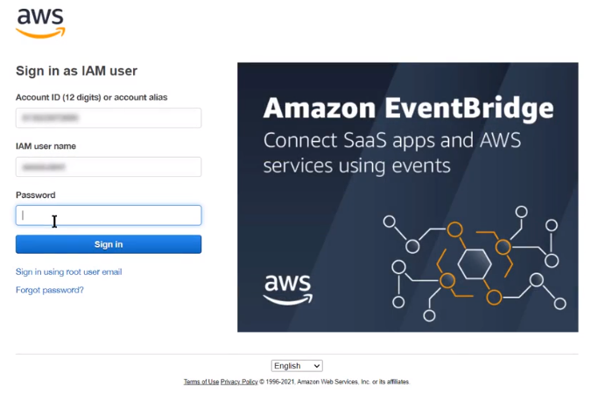

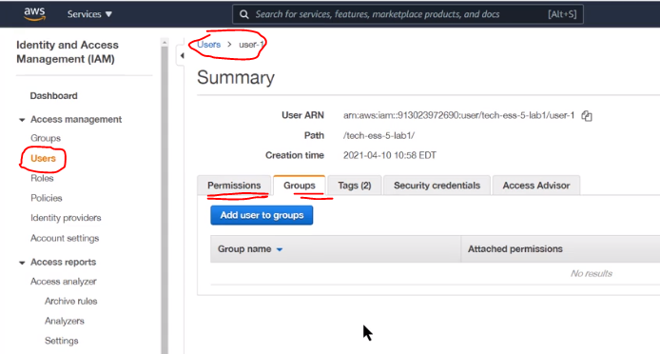

Here, we see in “Security credentials” tab that Console password has already been Enabled.

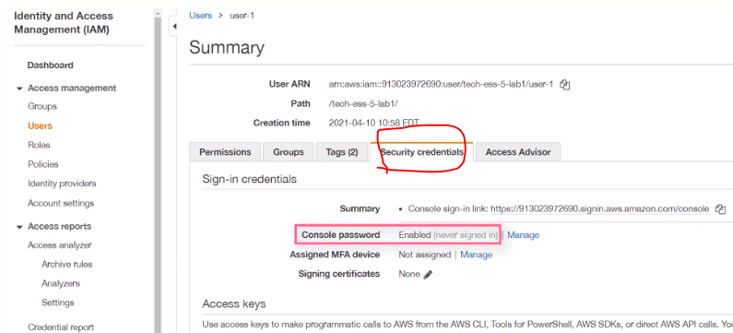

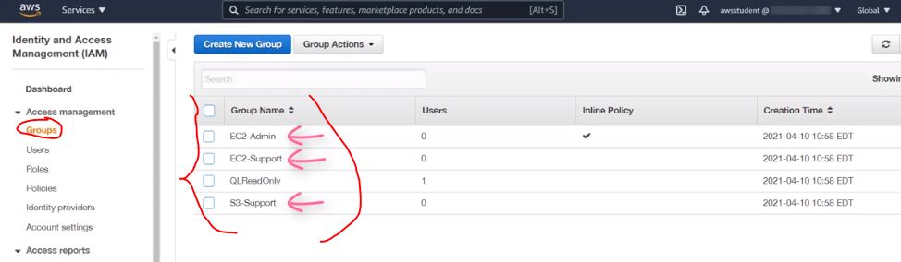

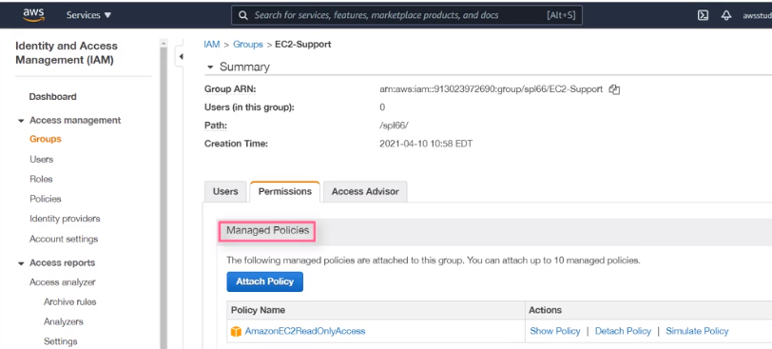

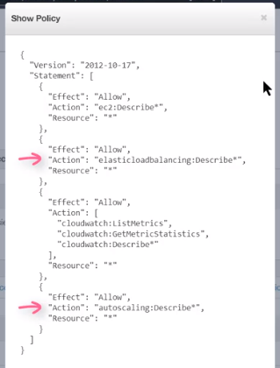

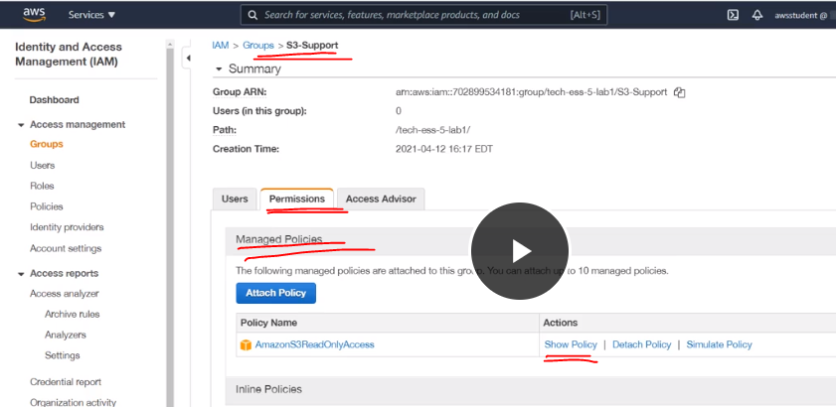

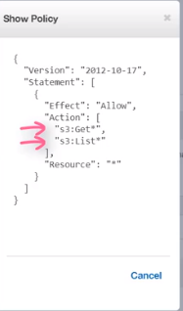

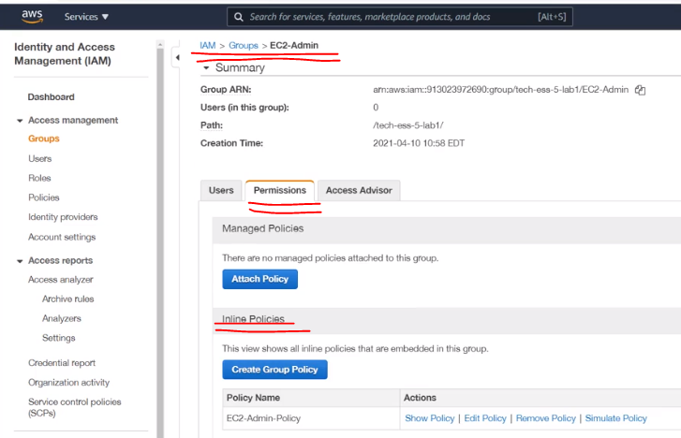

Here, it’s an “Inline Policy” that means the policy itself is embedded to the group itself and this also, gives us the ability to Edit the policy.

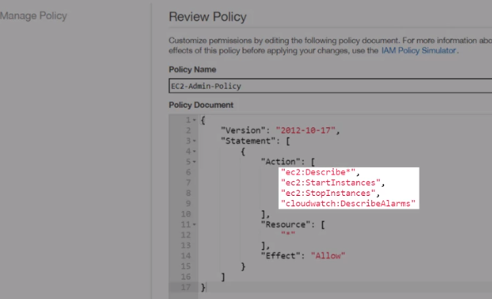

**Dashboard with Sign-in URL highlighted.**

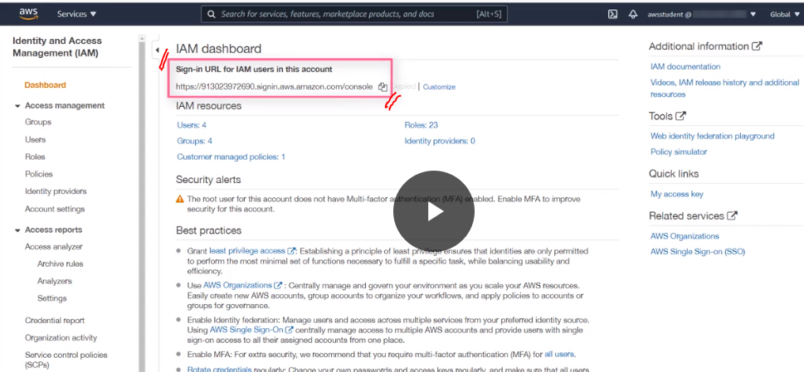

**Using the sign-in link and logging with user-1 credentials.**

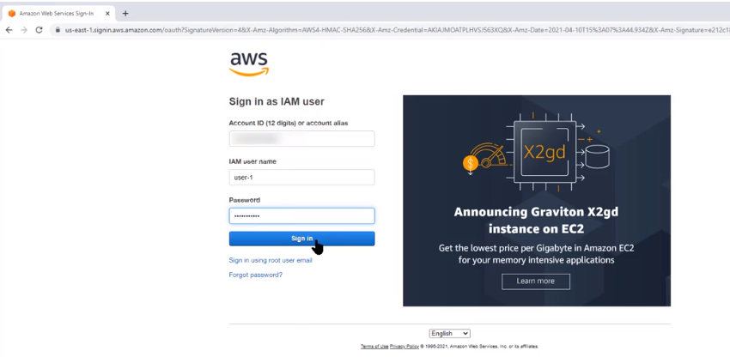

**Amazon S3 for user-1 showing its buckets**

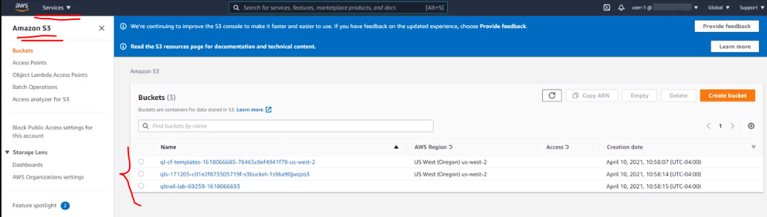

**The below snippet states that “Access” is successful as per the user-1 group policy applied.**

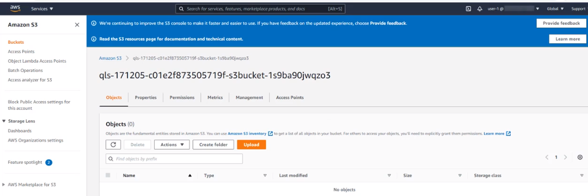

**The below snippet shows that there are no instances under Amazon EC2 for user-1 as expected due to group policy assigned (Read-only permission on Amazon S3).**

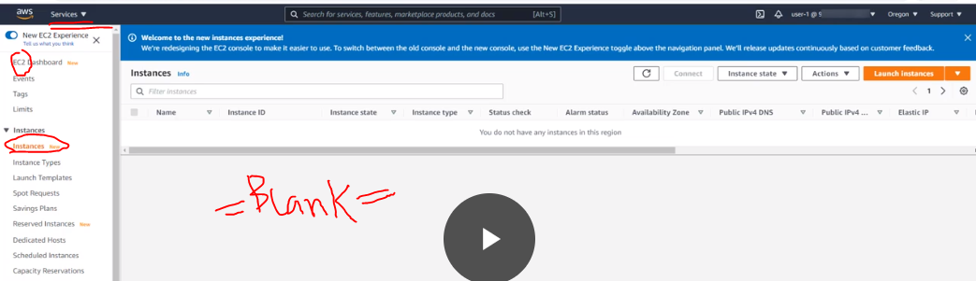

**The below snippet shows Amazon EC2 instances when logged-in using user-2 credentials.**

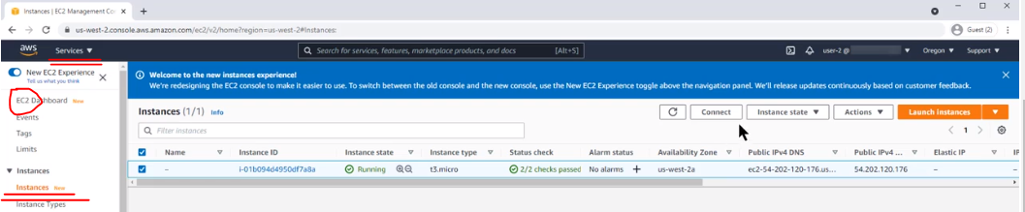

**The below 2 snippets shows that user-2 is not authorized to perform “Stop Instance” action as it has only read-only permission as per the group policy assigned.**

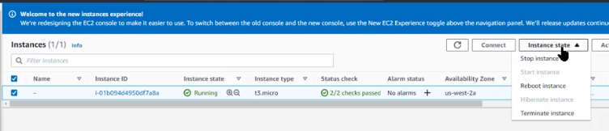

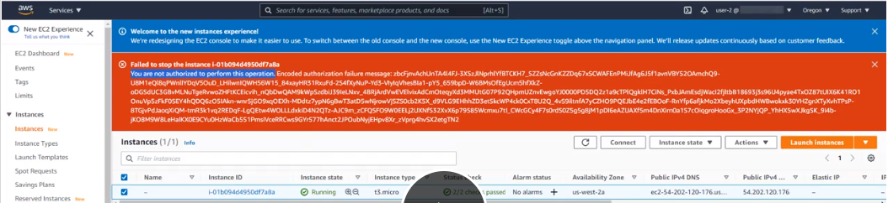

**The below snippet shows that “Stop Instance” action was successful after logging-in using user-3 credentials as per the group policy assignment.**

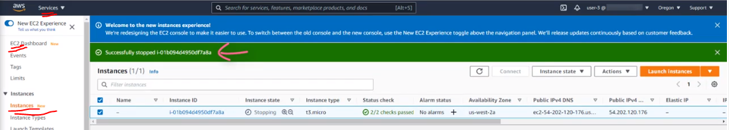

**Employee Directory Application Hosting**

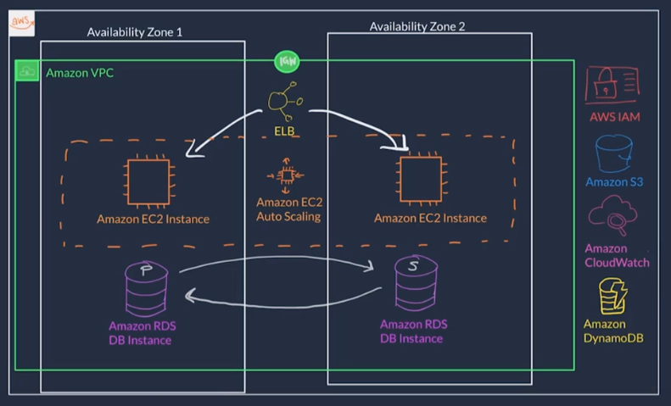

* AWS provides something called “Default VPC” which is private network for your AWS resources.
* We shall use the default network provided by AWS and default values for launching an AWS instance.
* An instance is nothing but one single virtual machine.

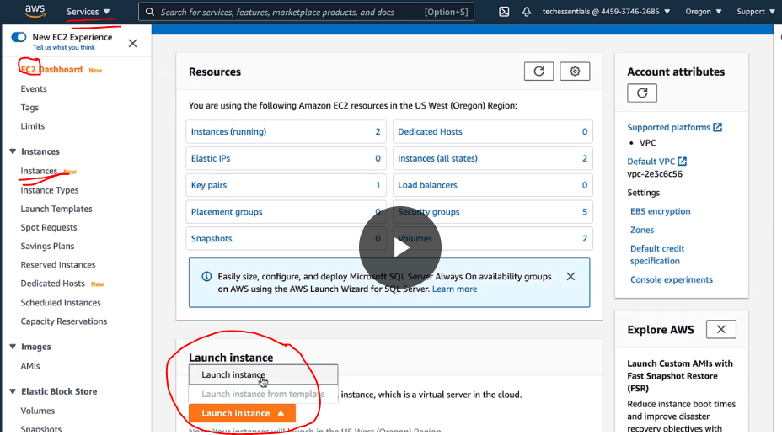

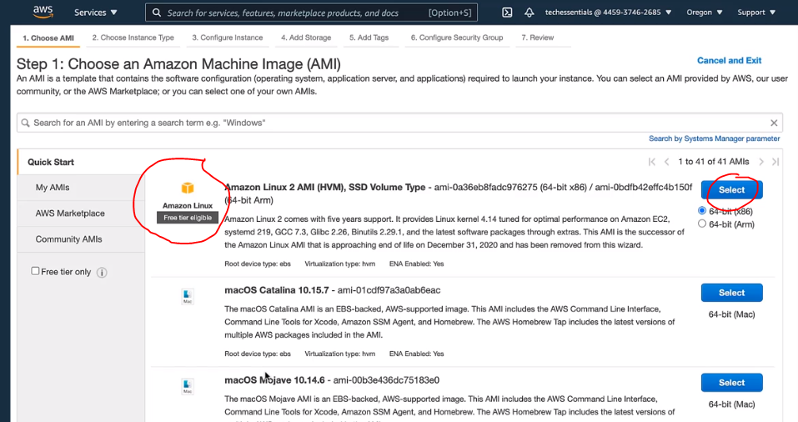

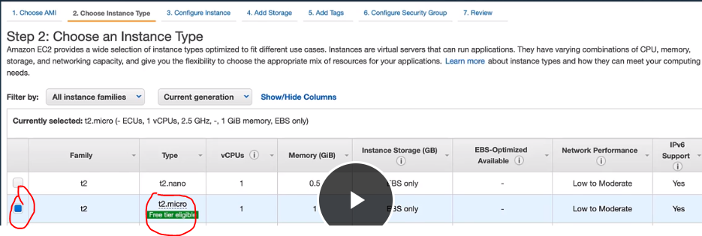

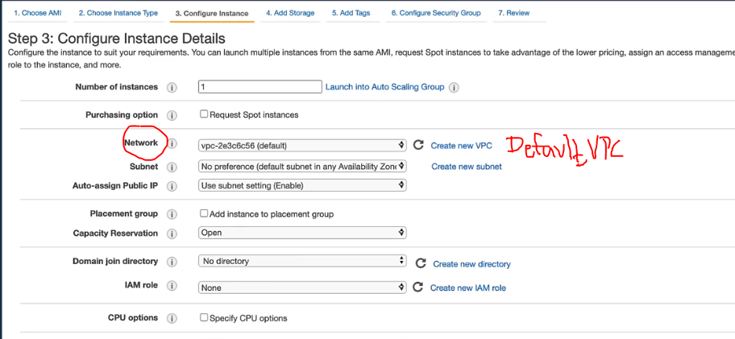

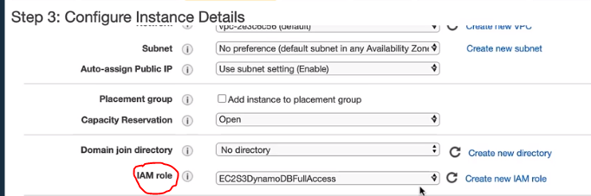

**This script under “User Data” will run when the instance boots up and do the following.**

* **Download the source code to the app.**
* **Start the web-server and**
* **Kick-off the application code.**

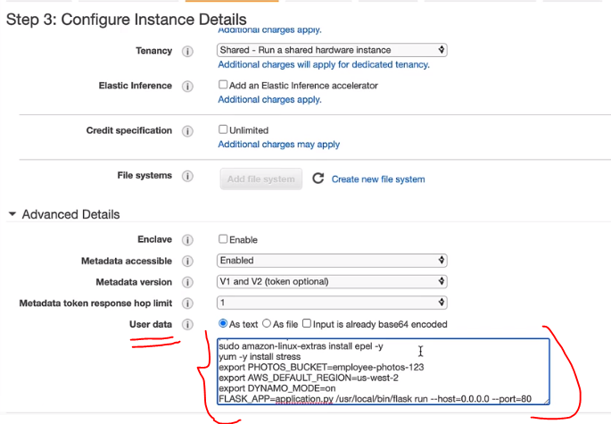

**Here, we give a name to our instance as “employee-webapp”**

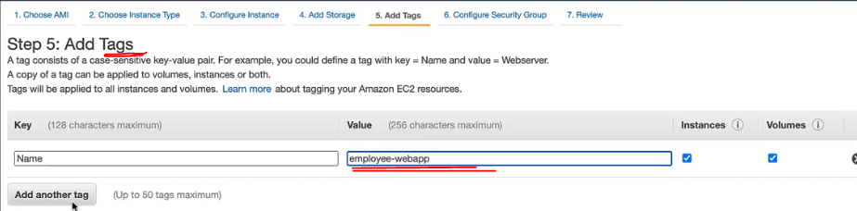

**Configure Security Group = This is an instance level firewall which will allow the HTTP and HTTPS requests to reach the instance.**

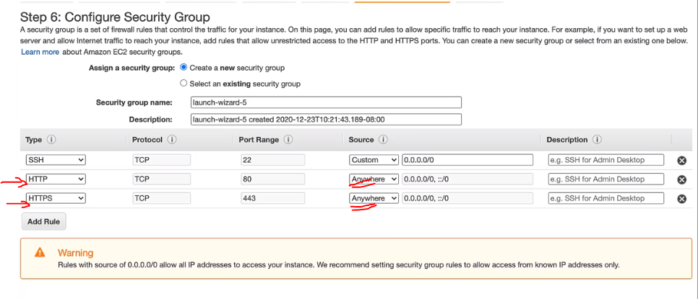

**Review and Launch**

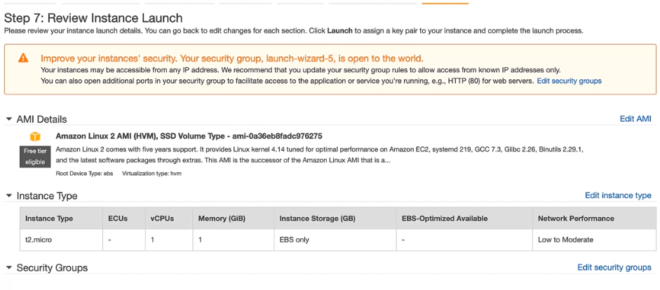

**Review the Key-Pair**

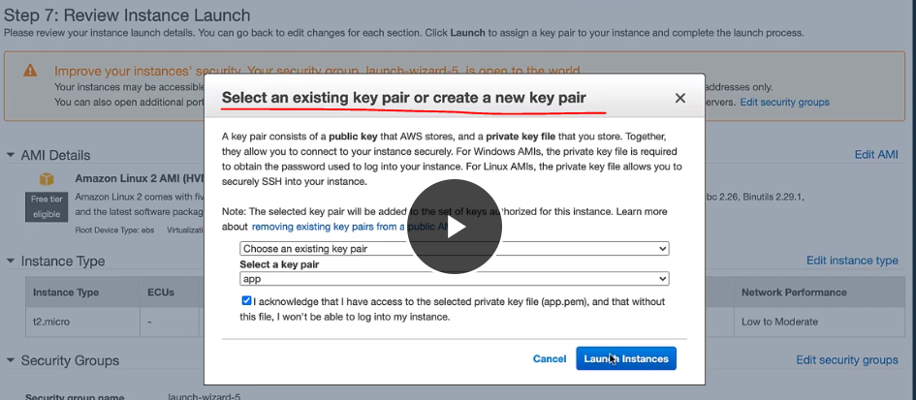

**Finally, the instance is up and running after booting up**

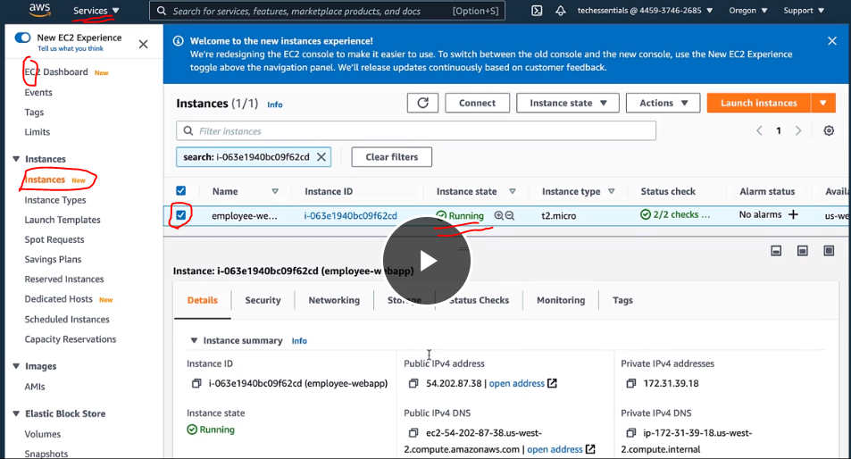

**Copy the Pubic IP address**

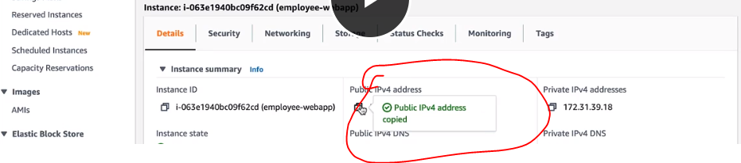

**At last, our employee directory application is up and running & as we do not have any data it shows a blank page.**

